1. **Independent Analysis and Forecast of Financial performance and Stock prices**
2. **FPT**

FPT Corporation is a leading technology company in Vietnam, providing a wide range of IT services, digital products, and solutions to clients worldwide. With over 30 years of experience in the industry, FPT has established itself as a trusted partner for businesses seeking innovative and reliable technology solutions. The company has a diversified portfolio of offerings, including software development, system integration, digital transformation, and cloud services, among others. FPT's strong market position and reputation have enabled the company to achieve steady growth in revenue and profit in recent years, despite the challenges posed by the COVID-19 pandemic.

This part aims to provide an independent analysis and forecast of FPT's financial performance based on key metric net sales and stock price forecast. The report will utilize several forecasting models, and the accuracy of each model will be assessed using metrics such as RMSE, MAPE, and AIC, to determine which model provides the most reliable forecast for FPT's financial performance and stock prices.

* 1. **Financial Analysis – Net Sales**

This part analysis about the Vinamilk’s net sales from the first quarter of 2009 to the fourth quarter of 2022 ( 57 observations).

***Figure 1.*** *Decompose the time series FPT Net Sales*

Figure 1 shows that FPT's net sales are seasonal. Here the trend is not really clear for the 14-year net sales data from 2009 to 2023. The objective of this section is to select an appropriate model for forecasting the company's quarterly net sales in 2023, based on the quarterly data from the past years.

8 different models use for forecasting in this part :

• Linear–Linear models:

**[1]** Only time trend

**[2]** Trend and seasonality in additive form

**[3]** Trend and seasonality in additive and multiplicative form

• Log-Linear models

**[4]** Only time trend

**[5]** Trend and seasonality in additive form:

**[6]** Trend and seasonality in additive and multiplicative form

• Holt-Winters models

**[7]** Additive form

**[8]** Multiplicative form

| **Model** | **Forecast 2023** | | | | **Full Dataset** | | **4 last obs (2022)** | |
| --- | --- | --- | --- | --- | --- | --- | --- | --- |
| **Q1** | **Q2** | **Q3** | **Q4** | **RMSE** | **MAPE** | **RMSE** | **MAPE** |
| **[1]** | 8388230 | 8363139 | 8338048 | 8312957 | 2860171.47 | 33.59% | 2961033.96 | **23.11%** |
| **[2]** | 6534021 | 4859590 | 7664643 | 9228322 | 2314702.68 | **27.87%** | 4010037.11 | 36.30% |
| **[3]** | 7236954 | 6914307 | 7132537 | 7458944 | 2595129.03 | 31.07% | 3988853.5 | 33.99% |
| **[4]** | 7278441 | 7245961 | 7213625 | 7181434 | 2646381.28 | 32.59% | 3999043.34 | 33.42% |
| **[5]** | 6568904 | 5241553 | 7541173 | 9351376 | 2344436.59 | 31.06% | 3879351.10 | 35.31% |
| **[6]** | 7148595 | 6865037 | 7079006 | 7404283 | 2622605.92 | 29.48% | 4045194.24 | 34.57% |
| **[7]** | 7172212 | 4689919 | 8181840 | 10283210 | 3430986.24 | 30.13% | 3611947.09 | 31.90% |
| **[8]** | 7445961 | 5036867 | 8241965 | 9858226 | 3328000.57 | 29.16% | 3514286.91 | 31.02% |

***Table 1.*** *Result analysis FPT Net Sales*

Table 1 shows the results of 8 different models. In general, there is not too much difference in results between models. For 4 last observation in 2022, model **Linear–Linear model with only time trend** **[1]** is the best, MAPE = 23.11%. For full dataset, **Model Linear model with Trend and seasonality in additive form [2] i**s the best, MAPE = 27.87%. We can also find model results is better when comparing MAPE on the last 4 observations and MAPE on the Full dataset.

* 1. **Stock price FPT forecasting using ARIMA**

FPT is a highly respected technology company in Vietnam, with a strong track record of solid revenue growth and profitability.FPT's financials are also robust, with the company reporting strong profitability and a healthy balance sheet. These factors have made FPT a popular investment option for investors looking for stable and reliable long-term growth potential.

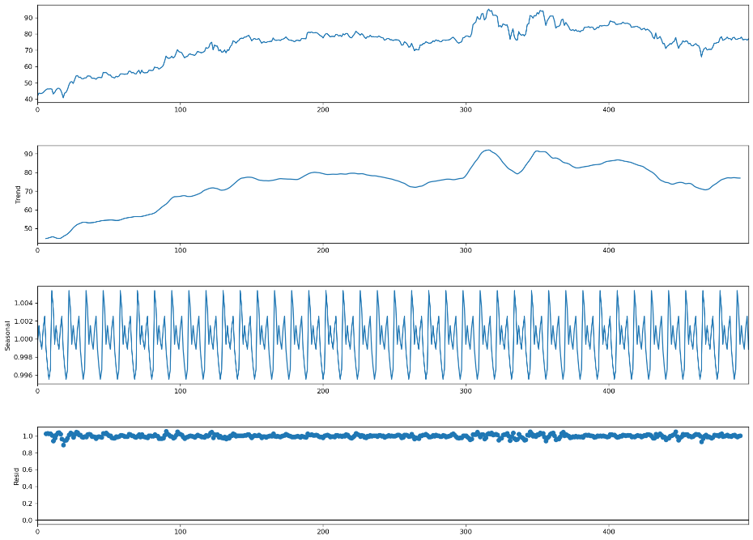

***Figure 2.*** *Decompose the FPT stock price 2021-2022*

Figure 2 shows that FPT stock from 2021 to 2022 has an upward trend, with seasonality, and non-stationary. So, i will take difference of the fpt stock.

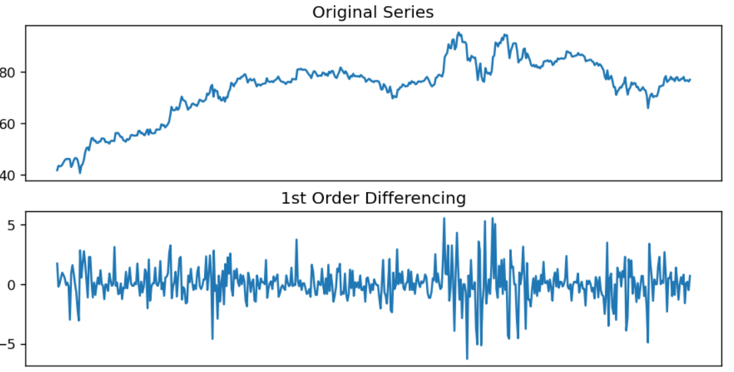

***Figure 3.*** *Orginal and 1st Order Differencing of FPT stock price 2021-2022*

After take 1st Order Differencing, Figure 3 shows that 1st Order Differencing is stationary. Augmented Dickey-Fuller Test gives similar results to 1st Order Differencing

***Figure 4.*** *1st Order Differencing and PACF, ACF of FPT stock price 2021-2022*

It is difficult to determine order AR, MA according to ACF and PACF to choose the best model. So I used AIC to find the best model, and the result is ARIMA (7,1,13) is the best model. I also test with ARIMA(4,1,5), ARIMA(2,1,2).

| **Model** | **Prob(Q)** | **RMSE** | **AIC** | **BIC** |
| --- | --- | --- | --- | --- |
| ARIMA(7,1,13) | 0.96 | 2.32351 | 1773.690 | 1808.393 |
| ARIMA(4,1,5) | 0.84 | 2.34304 | 1774.717 | 1816.823 |
| ARIMA(2,1,2) | 0.95 | 2.36168 | 1786.036 | 1807.089 |

***Table 2.*** *Evaluation of ARIMA models*

***Figure 5.*** *ARIMA(7,1,13) Inverse roots*

***Figure 6.*** *Residuals checking for ARIMA(7,1,13)*

From figure 5 and figure 6, it can conclude that there is no serial correlation in the residuals of the model, and the reverse roots are inside the unit circle